High level Architecture

P09:InterviewPrepApp

Student ID | Name
26100314 | Abdul Samad
26100049 | Abdul Rehman
26100401 | Muhammad kabli
26100251 | Ahmed bilal
26100032 | Haider Abbas Virk

Content | Total | Obtained
Introduction | 5 | 5
Non-functional requirements | 5 | 5
Security requirements | 5 | 5
Project risk management | 25 | 25
Architecture diagram | 50 | 40
Architecture description | 20 | 20
Architecture justification | 40 | 40
Tools & Technologies | 10 | 10
Hardware Requirements | 5 | 5
Development env. preparation | 10 | 10
Deployment platform | 5 | 5
Use of generative AI | 5 | 5
Who did what | 5 | 5
Review checklist | 5 | 5
Overall formatting | 5 | 5
Late submission penalty | -20
Grand Total | 200 | 190
General Comments/Individual Grading:

Table of Contents

1. Introduction 3
2. Non-functional requirements/Quality attributes of the system 4
3. Security Requirements 5
4. Project Risk Management 6
4.1 Potential Project Risks and Mitigation Strategies 6
5. System Architecture 7
5.1 Architecture Diagram 7
5.2 Architecture Description 8
5.3 Justification of the Architecture 9
6. Tools and Technologies 13
7. Hardware Requirements 14
8. Development Environment Preparation 15
9. Deployment Platform 15
10. Use of Generative AI 16
11. Who Did What? 17
12. Review checklist 17

Introduction

This project is an AI-powered interview preparation platform that allows job seekers to simulate real interview scenarios. The system collects job-related data from the user, generates role-specific questions using a large language model, and conducts a mock interview through conversational AI (e.g., Vapi or ElevenLabs assistant). After the session, the system provides feedback on user performance, covering aspects such as communication clarity, confidence, technical correctness, and behavioral structure (e.g., STAR method).
Objectives:
- Help students and professionals prepare effectively for job interviews.
- Provide personalized, role-specific, and skill-specific mock interviews.
- Deliver actionable feedback to improve communication and technical skills.
Potential Users:
- University students preparing for placements.
- Professionals switching jobs or industries.
- Career counseling and training centers.

Non-functional requirements/Quality attributes of the system

Sr# | Requirements
1 | The system shall generate the first interview question within 5 seconds after job details are provided.
2 | The system shall generate follow-up questions within 2 seconds after a candidate’s response.
3 | The system shall maintain 99.5% uptime and recover from crashes within 5 minutes.
4 | All user data and interview sessions shall be stored with encryption at rest and in transit.
5 | The system shall support up to 500 concurrent interview sessions without performance degradation.
6 | The user interface shall be responsive and accessible on desktop and mobile devices.
7 | The system shall provide a feedback report within 15 seconds after interview completion.

Security Requirements

Sr# | Security Risks | Potential Losses | Controls
1 | Input Manipulation Attack | Misleading feedback leading to loss of customers | Input validation & sanitization for all uploads
2 | Data Poisoning Attack | Cost to retrain models and clean datasets | Strict data provenance and vetting
3 | AI Supply Chain Attacks | Compromise of your app or models leading to data leaks | Use vetted sources, pin versions, verify checksums, and signatures for model binaries and packages.
4 | Broken Authentication | Unauthorized access to personal data | Use robust authentication like MFA, JWT
5 | Unrestricted Resource Consumption | Degraded performance for real users | Monitor resource usage and apply circuit breakers
6 | Unsafe Consumption of APIs | Collateral breaches via third-party integrations | Validate all data from external APIs

Project Risk Management

Potential Project Risks and Mitigation Strategies

Sr. | Risk Description | Mitigation Strategy
 | Staff turnover  Experienced staff leaves the project before it is finished. | Maintain detailed technical documentation and version control for all modules (backend, ML models, UI). Cross-train team members to ensure role redundancy and continuity. Conduct regular code reviews and maintain centralized repositories on GitHub.
 | Requirements change  Changes in requirements that require major design rework are proposed. | Use an iterative agile model with flexible sprints. Maintain versioned requirement specifications and impact analysis before approving new changes. Employ modular architecture to minimize system-wide disruptions.
 | Underestimation  The size of the system is underestimated. | Conduct early feasibility studies and prototype testing. Include a 20–25% contingency buffer in timeline and resource estimates. Schedule regular progress reviews to recalibrate scope based on observed effort.
 | Technology change  The underlying technology on which the system is built is superseded by a new technology. | Use containerized deployments (e.g., Docker) and abstracted APIs for easy substitution of components. Continuously monitor industry trends and plan for version upgrades during maintenance cycles.
 | Code generation  The code generated by generative AI is inefficient. | Enforce human-in-the-loop validation. Apply static code analysis, linting, and unit testing for all AI-generated code. Establish coding standards and conduct peer reviews before integration.
 | Data  Required data is not available. The required data may be for training of ML Model or for some other purpose. | Maintain data backups and build a synthetic data generation pipeline using LLMs and augmentation. Define minimum viable dataset thresholds before model training. Obtain user consent for anonymized data collection.
 | Stakeholder management  Customers fail to understand the impact of requirements change. | Conduct regular stakeholder meetings and demos. Provide transparent progress tracking and clear documentation of trade-offs for change requests. Maintain formal change approval workflows.
 | Off-the-shelf components and libraries  Software components/libraries that were planned to be used do not contain desired features or contain defects, i.e., they cannot be used as planned. | Select well-maintained open-source or licensed libraries with active support. Track library versions and vulnerabilities. Maintain fallback alternatives and perform dependency audits regularly.

System Architecture

InterviewPrepApp is designed as a hybrid event-driven microservices architecture with Next.js acting as the gateway and orchestrator. The system separates concerns into specialized services that communicate via an event bus (Pub/Sub). This enables low-latency, highly parallel processing of time-sensitive interview flows (TTS → user answer → ASR → LLM → next-question) while keeping developer velocity high through serverless and managed services.

Key characteristics:

- Hybrid: Next.js handles client-facing pages and API routes; serverless microservices (Cloud Functions / serverless containers) handle heavy real-time processing and background tasks.

- Event-driven: Domain events (e.g., session_started, voice_transcribed, question_generated, session_ended) are published to a message broker; microservices subscribe and react independently.

- Pluggable external providers: Clerk for auth, ElevenLabs / Vapi for TTS/ASR, OpenAI/Gemini for LLM tasks, Firebase / MongoDB for persistence.

- Goals achieved: low follow-up latency (≤ 2s), fast first-question (≤ 5s), report generation (≤ 15s), and support for ≥ 500 concurrent interview sessions.

Architecture Diagram
Add some high-level components of your system in client. How this architecture handles large number of requests?
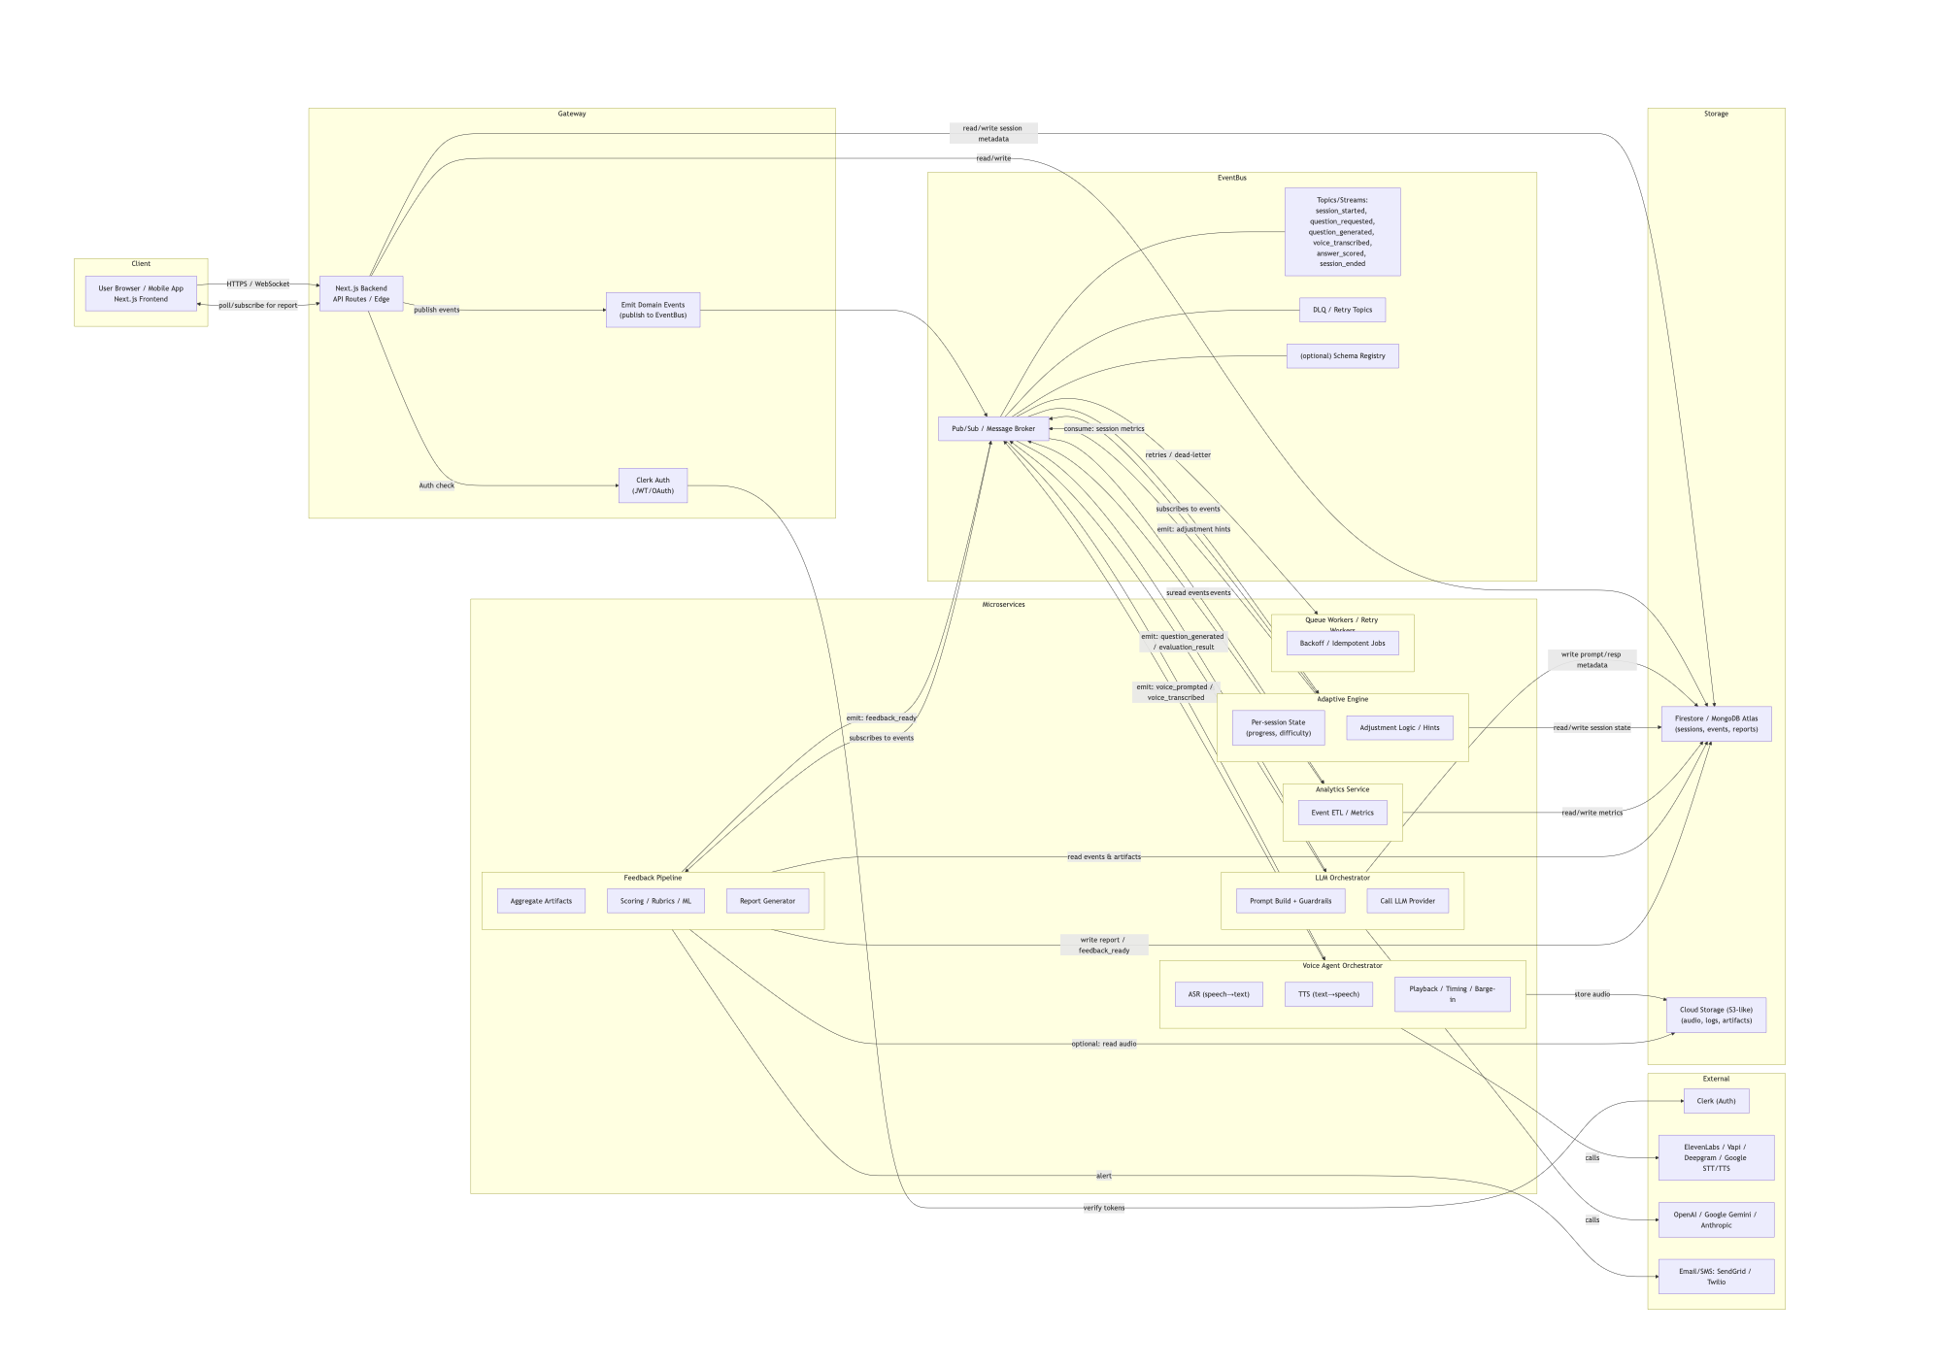

Architecture Description

Below each subsystem is described with purpose, responsibilities, triggers/events, inputs/outputs, and example implementations.

1 - Next.js Backend (API Gateway & Orchestrator)

Purpose:
Single entry point for client traffic; authenticates requests, validates inputs, manages session lifecycle, and publishes high-level domain events to the event bus.

Responsibilities:
- Authenticate users via Clerk JWTs and enforce role-based access (user/evaluator/admin).
- Session lifecycle: create session, set session options (topic/difficulty), close session.
- Publish domain events to EventBus (e.g., session_started, question_requested, session_ended).
- Provide endpoints for retrieving reports, pre-signed uploads, and admin operations.

Triggers / Events:
- HTTP endpoints: /api/startSession, /api/emitAnswer, /api/endSession, /api/getReport.
- Publishes to event bus and writes minimal session metadata to DB.
Inputs / Outputs
- Input: client requests with Clerk-authenticated JWT and metadata.
- Output: events to EventBus; DB writes for session metadata.
Implementation examples
- Next.js App Router (Vercel), Vercel Edge functions for low-latency endpoints. Alternatives: Node.js Express gateway on serverless or Kubernetes.

2 - Clerk (Authentication & Identity)

Purpose:
Provide managed secure authentication, user lifecycle, MFA, and identity management.

Responsibilities:
- Sign-up/login flows; token issuance (JWT) and session refresh.
- Role claims in tokens (admin/evaluator/user).
- Single source of truth for user identity.

Integration:
- Next.js verifies Clerk JWT on each API call.
- Clerk’s webhooks can trigger account-related events in EventBus if needed.

Examples:
- Clerk (preferred), alternatives: Auth0, Firebase Auth, Okta.

3 - Event Bus / Message Broker

Purpose:
Decouple producers and consumers via asynchronous messaging; enable retries, buffering, and parallelism.

Responsibilities:
- Publish/subscribe semantics, dead-letter queue support, at-least-once delivery, optional ordering guarantees for partitions that require them.
- Carry events like session_started, question_generated, voice_transcribed, session_ended, feedback_ready.
Implementation examples:
- Managed: Firebase Pub/Sub, Google Cloud Pub/Sub, AWS SNS+SQS.
- Self-hosted: Kafka, RabbitMQ, NATS.
- Recommendation: start with Firebase Pub/Sub or Google Pub/Sub for integration simplicity; migrate to Kafka if throughput/ordering demands grow.

4 - Voice Agent Orchestrator

Purpose:
Handle all audio concerns: TTS generation for questions, recording/streaming user audio, ASR transcription, barge-in and timing/turn-taking logic.

Responsibilities:
- On question_generated, call ElevenLabs or Vapi TTS, store TTS audio to object storage, emit voice_prompted event.
- Accept audio uploads or streams from client; assemble chunks; call ASR (ElevenLabs/Vapi/Deepgram/Google STT); emit voice_transcribed.
- Manage timeouts, retries, handle VAD (voice activity detection) for segmentation.

Inputs / Outputs:
- Input: question_generated event, client audio uploads/streams.
- Output: voice_prompted, voice_transcribed events; audio stored in OBJ.

Examples:
- Implementation: Node.js Cloud Function / serverless container.
- Providers: ElevenLabs (TTS, ASR where supported), Vapi (ASR), Deepgram, Google Speech-to-Text.

5 - LLM Orchestrator (Prompt Manager)

Purpose:
Build, sanitize, and send prompts to LLMs; capture responses, apply content policies, and store prompt/response metadata for audit.

Responsibilities:
- Compose prompts using session context, question bank, and adaptive-engine inputs.
- Sanitize user transcripts (PII redaction if necessary) before sending to LLM.
- Apply safety filters to LLM outputs and choose fallbacks if content fails policy.
- Pin and record model versions used (for audit and supply-chain integrity).

Inputs / Outputs:
- Input: voice_transcribed, or question_request events; adaptive engine suggestions.
- Output: question_generated, evaluation_result events.
Examples:
- Implementation: serverless function in Node.js or Python.
- Providers: OpenAI (GPT family), Google Gemini, Anthropic. Use prompt templates and caching (Redis).

6 - Adaptive Engine

Purpose:
Real-time personalization engine that decides question difficulty and route of follow-ups based on user performance signals.

Responsibilities:
- Maintain per-session state (difficulty, history) in a fast store (Redis) or DB.
- Consume scoring signals (e.g., answer_scored) and latency/clarity metrics to update difficulty.
- Emit adjustment events or update LLM Orchestrator inputs.

Inputs / Outputs:
- Input: answer_scored, voice_transcribed, session metrics.
- Output: difficulty updates, adjustment for LLM Orchestrator.

Examples:
- Implementation: lightweight Python service (FastAPI) or serverless function.
- Models: heuristics or small ML models (logistic regression, light MLP), persisted in ONNX/TensorFlow Lite if needed.

7 - Feedback Pipeline (Scoring & Report Generation)

Purpose:
Aggregate all session artifacts and produce structured feedback and human-readable reports.

Responsibilities:
- Triggered by session_ended. Aggregate transcripts, audio metrics, LLM evaluations, and adaptive-engine history.
- Run scoring heuristics + ML models (clarity, STAR structure, content relevance).
- Optionally call LLM to generate qualitative summaries and suggestions.
- Persist report and emit feedback_ready. Provide hooks for evaluator adjustments.

Inputs / Outputs:
- Input: session artifacts from DB and OBJ; possibly evaluation_result events.
- Output: final report stored in DB/OBJ; feedback_ready event.

Examples:
- Implementation: background worker (Cloud Function) with scikit-learn/torch models and LLM summarization.
- Libraries: librosa for audio features; scikit-learn or PyTorch for scoring models.

8 - Analytics Service

Purpose:
Collect telemetry for SLOs, business KPIs, and system health; power dashboards and alerts.

Responsibilities:
- Subscribe to events or copy event stream to a data warehouse.
- Store aggregated metrics (avg latencies, concurrency, error rates).
- Create dashboards (Grafana, BigQuery/Looker) and SLO alerts.

Examples:
- Implementation: push events to BigQuery, Prometheus + Grafana, or use Firebase Analytics / Google Cloud Monitoring.

9 - Storage: DB & Object Store

Purpose:
Persist structured metadata, transcripts, models, and binary media (audio files, TTS audio, reports).

Responsibilities
- DB: store users, sessions, transcripts index, question bank, audit logs, evaluation scores.
- OBJ: store raw audio chunks, assembled recordings, TTS audio, and generated reports.

Examples
- DB: Firebase Firestore (serverless NoSQL) or MongoDB Atlas (document DB); optionally Postgres if relational needs arise.
- Object Storage: Firebase Storage, Amazon S3, Google Cloud Storage.

10 - Admin / Evaluator Portal

Purpose:
Human-in-the-loop tools — review flags, change scores, manage question bank, and export reports.

Responsibilities
- Role-based UI, protected routes via Clerk roles.
- Audit trail for manual score edits and content moderation.
- Tools to download audio, transcripts, and mark re-evaluations.

Examples
- Implementation: Next.js protected pages with React components (TanStack Table for data grids, charts via Recharts).

11 - Observability, Security, and Ops

Purpose:
Ensure availability, detect anomalies, protect system and data, and provide SRE tooling.
Responsibilities

- Logging: central logs via Sentry/Datadog; tracing with OpenTelemetry; metrics in Prometheus/GCM.
- Secrets: KMS or Secret Manager for tokens and keys.
- WAF / Rate Limiting: Cloudflare / Cloud Armor; gateway-level rate limiting for abuse prevention.
- Auditing: store model ids, prompt hashes, timestamps for every LLM call.
- Backups and retention policies: scheduled backups and data retention rules.

Examples
- Tools: Sentry, Datadog, Grafana, OpenTelemetry, Google Secret Manager, Cloudflare WAF.

How subsystems interact with each other (sequence & integration)
Below is the typical sequence of interactions and the responsibilities each subsystem assumes at each step.
1 - Start interview (sequence)
- User (Next.js Client) authenticates via Clerk and calls POST /api/startSession.
- Next.js Backend validates request and writes initial session metadata to DB, then publishes session_started to EventBus (includes sessionId, difficulty, topic).
- LLM Orchestrator subscribes to session_started, composes a starter prompt and calls LLM provider; emits question_generated (with question text and metadata).
- Voice Agent Orchestrator receives question_generated, calls TTS provider (ElevenLabs/Vapi), stores TTS audio to OBJ and emits voice_prompted.
- Client plays TTS audio and prompts the user to answer.
2 - Answering & follow-up (sequence)
- Client records user's response in small chunks and streams/uploads them, signaling Next.js that audio is being uploaded (or sends an answer_chunk event).
- Voice Agent Orchestrator (or an ingestion worker) sends audio to ASR; upon receiving transcription, it emits voice_transcribed (with transcriptId, transcript text, confidence).
- LLM Orchestrator consumes voice_transcribed, the Adaptive Engine provides difficulty adjustments (based on prior answer_scored events), LLM Orchestrator calls LLM to generate follow-up or next question, then emits question_generated.
- Voice Agent Orchestrator repeats TTS, storing audio and emitting voice_prompted. The client plays the audio and the flow continues.
3 - Session end & feedback (sequence)
- Client signals end of session (/api/endSession) → Next.js publishes session_ended.
- Feedback Pipeline subscribes to session_ended, aggregates session artifacts (transcripts, audio refs, scoring outputs), runs scoring models, optionally calls LLM to synthesize a human-friendly report, and stores the result to DB/OBJ; emits feedback_ready.
- Next.js receives feedback_ready (or checks DB) and notifies the user via the UI or email/SMS; admin evaluators can review or adjust via the Admin Portal.

4 - Analytics & monitoring
- Analytics Service subscribes to many events (or copies event stream) to compute SLO metrics, error rates, concurrency, and model performance trends. Alarms are raised when thresholds cross.

Justification of the Architecture
This architecture is chosen because InterviewPrepApp is:
- Interaction-heavy: dialogues require tight timing between question generation, TTS, user response capture, and LLM-based follow-ups. An event-driven model maps naturally to discrete conversational events and enables parallelism.
- Latency-sensitive: follow-ups must be produced within ≤ 2s; streaming ASR + event-driven orchestration minimizes blocking and enables immediate upstream/downstream work.
- Scalability-demanding: anticipated concurrent sessions (≥ 500) are handled by independently scaling microservices and an event bus to buffer spikes.
- AI-integrated: multiple LLM & ASR calls per session are best handled by an orchestrator that can cache, apply safety filters, and fallback when providers are slow.
- Auditable & secure: the architecture supports logging every LLM call, model version pinning, and cryptographically managed secrets, which are critical for compliance and reproducibility.

- Pros and cons of the architecture
Pros | Cons
- Scalability — independent scaling of Voice, LLM, Feedback services; event bus buffers spikes.  - Low-latency parallelism — TTS, ASR, and LLM operations can run in parallel and don’t block the orchestrator.  - Resilience & fault isolation — single-service failures do not bring the whole system down. Dead-letter queues and retries increase robustness.  - Extensibility — easily swap or upgrade providers (ElevenLabs → Deepgram, OpenAI → Gemini) without large refactors.  - Auditable & versioned AI usage — model versions recorded for each LLM call; helps compliance and debugging.  - Developer speed — Next.js + serverless functions allow rapid iteration for the web and admin UIs. | - Operational complexity — monitoring, tracing, and debugging an event-driven system require stronger SRE tooling.  - Testing overhead — E2E tests need mocks for ASR/LLM and replayable event streams.  - Cold-starts in serverless — can cause variable latency; needs warming strategies or provisioned concurrency for critical functions.  - Cost — using LLM + ASR at scale can be expensive; must implement cost controls and batching where possible.  - Eventual consistency — data may not be instantaneously visible across services; design must handle eventual consistency semantics.

- Implementation of non-functional requirements in system architecture

Requirement | First question ≤ 5s; follow-ups ≤ 2s.
Implementation in the architecture | - Pre-fetch and cache starter prompts in QuestionBank (Redis) at session start.  - Use streaming ASR (ElevenLabs/Vapi or Deepgram) to obtain partial transcripts quickly.  - Use next-question precomputation: run LLM generator as soon as transcription begins (speculative execution).  - Deploy Next.js API routes on Edge (Vercel) to reduce round-trip time.

Requirement | Support ≥ 500 concurrent sessions.
Implementation in the architecture | - Event-driven microservices scale horizontally; broker partitions work across instances.  - Serverless functions auto-scale on demand.  - Background processing for heavy tasks (feedback scoring) to keep real-time path lean.  - Load test with realistic audio and LLM latencies; instrument autoscaling boundaries.

Requirement | 99.5% uptime; recover failures quickly.
Implementation in the architecture | - Use managed multi-zone services (Vercel, Firebase, MongoDB Atlas) for high availability.  - Implement health checks, circuit breakers, retries, and dead-letter queues.  - Observe and alert via Prometheus/GCM/Grafana + runbooks for incident response.  - Prepare fallback flows: cached templates if LLM or ASR is unavailable.

Requirement | Report available ≤ 15s after session end.
Implementation in the architecture | - Feedback Pipeline performs much of its computation in parallel during the session (incremental scoring), so final aggregation is fast.  - Use in-memory scoring where possible; keep heavier batch processing for post-hoc analytics.  - Precompute per-turn scores as each voice_transcribed event arrives so the final aggregation is an O(n) combine.

Requirement | Secure authentication, role-based access.
Implementation in the architecture | - Clerk handles MFA, secure sessions, and role claims. Next.js verifies tokens for API access.  - Database access enforced by Firestore security rules and DB-level roles for MongoDB.  - Do not accept unauthenticated events; require signed event tokens if external webhooks are used.

Requirement | Encryption, consent, retention, right-to-be-forgotten.
Implementation in the architecture | - TLS in transit; encryption at rest via cloud provider KMS.  - Implement consent flags in user profile; store PII only when necessary and redact transcripts by default.  - Provide deletion workflow that removes DB records and scheduled OBJ deletions.  - Hash audio file names; keep minimal identifying metadata in logs.

- Implementation of security requirements in system architecture

Security Risk | Input Manipulation Attack  Attackers may inject malicious inputs (e.g., malformed JSON, scripts, or manipulated audio/text) to mislead AI models or cause inaccurate feedback.
Implementation in the architecture | Front-end Validation: User inputs (text, audio uploads, parameters) are validated and sanitized client-side before submission.  Next.js API Gateway: Performs strict schema validation using JSON schema libraries (e.g., zod, Joi) before data is passed downstream.  LLM Orchestrator: Applies additional sanitization and content-filtering before embedding user transcripts into prompts.  Clerk Authentication: Ensures only authenticated sessions can submit data.  Message Broker (Pub/Sub): Filters and rejects events missing required metadata, ensuring integrity across microservices.  Encryption: All communication between client, gateway, and microservices uses HTTPS/TLS.

Security Risk | Data Poisoning Attack  Malicious or mislabeled data could enter the training or evaluation pipeline, compromising model integrity and leading to biased or incorrect AI feedback.
Implementation in the Architecture | Feedback Pipeline: Only stores session data from verified, authenticated users.  Data Provenance Enforcement: Every data artifact (transcript, report, score) is tagged with session IDs, user IDs (from Clerk), and timestamps for traceability.  Restricted Write Access: Only the Feedback Pipeline microservice can write to the training dataset bucket in Cloud Storage (OBJ).  Versioned Datasets: Firebase/Firestore keeps immutable versions of datasets; rollback possible if poisoning detected.  Analytics Service: Periodically monitors dataset anomalies (outliers, duplication) to flag potential poisoning.

Security Risk | AI Supply Chain Attacks  Compromised AI model binaries, libraries, or external APIs could inject malicious code or exfiltrate data.
Implementation in the architecture | LLM Orchestrator: Uses pinned model versions (e.g., specific GPT or Gemini model IDs) with recorded hashes and signatures.  Deployment Control: CI/CD pipeline verifies checksums and package signatures of dependencies before build.  Secret Management: API keys for OpenAI, Gemini, or ElevenLabs are stored securely in Google Secret Manager or Vercel Environment Variables, never in code.  Read-only File Systems: Containerized microservices use read-only runtimes to prevent tampering with deployed binaries.  Audit Logging: Model versions, API endpoints, and timestamps are logged to Firestore for traceability.

Security Risk | Broken Authentication  Unauthorized users could access personal data, session artifacts, or administrative tools.
Implementation in the architecture | Clerk Authentication Service: Provides secure login with MFA, OAuth, and JWTs.  Next.js API Gateway: Verifies Clerk-issued JWTs before routing to internal services; rejects expired or invalid tokens.  Role-Based Access: Clerk roles (user/evaluator/admin) determine what API routes and UI views are available.  Private Network Access: Internal microservices (LLM Orchestrator, Feedback Pipeline) are only reachable via the Gateway and cannot be directly accessed publicly.  Session Isolation: Each user’s session data (transcripts, scores, reports) is scoped by unique Clerk user ID and Firestore security rules.

Security Risk | Unrestricted Resource Consumption  Excessive or malicious API usage (e.g., too many sessions, audio uploads, or LLM calls) could exhaust resources, slow down legitimate users, or incur high costs.
Implementation in the architecture | API Gateway Rate Limiting: Uses Upstash or Cloudflare rate limits to restrict requests per user/session.  Circuit Breakers: Implemented in LLM Orchestrator and Voice Agent Orchestrator to temporarily halt requests when latency or errors spike.  Adaptive Engine: Monitors per-user resource usage and dynamically adjusts concurrency or session limits.  Broker-Level Quotas: Pub/Sub enforces per-topic rate caps; messages exceeding quota are throttled or queued.  Monitoring & Alerts: Analytics Service tracks resource consumption and sends alerts when thresholds exceed defined limits.

Security Risk | Unsafe Consumption of APIs  Insecure handling of responses from external APIs (ASR/TTS/LLM) could expose sensitive data or trigger logic flaws if unexpected payloads are returned.
Implementation in the architecture | LLM Orchestrator & Voice Agent Orchestrator: Validate all incoming API responses (schema validation, null checks, size limits).  Strict Output Parsing: Responses from LLMs are parsed using deterministic JSON schemas or function-calling interfaces, never executed as code.  Network Controls: Outbound connections restricted to whitelisted domains (e.g., api.elevenlabs.io, api.openai.com).  Content Filtering: Results from LLMs are passed through toxicity and PII filters before displaying to users.  Monitoring: Unexpected response patterns or payload anomalies logged to Analytics and flagged.

Tools and Technologies

Category | Tools & Versions | Purpose / Notes
Frontend | React 18.2.0  Next.js 15.5.4 (App Router)  JavaScript ES15  Tailwind CSS 4.1.14  React Query v5 | Frontend UI development, styling, and efficient data fetching.
Backend / API | Node.js 24.9.0  Express 5.1.0  JWT 9.0.2  Passport.js 0.7.0 | Core backend logic, REST APIs, and user authentication.
ML / AI Services | Python 3.14.0  PyTorch 2.8.0  Hugging Face Transformers 4.56+  FastAPI 0.118.0 | Machine learning model training, NLP, inference APIs.
Speech & Conversational | OpenAI Whisper v3  ElevenLabs TTS API v3 | Speech-to-text, text-to-speech, and real-time voice interaction.
Asynchronous Processing | Redis 8.0.4  Celery 5.5.3 | For background tasks like transcription, scoring, and report generation
Databases & Storage | MongoDB  Amazon S3 / MinIO | Persistent storage for user data and session recordings.
Deployment & DevOps | Docker 28.5.0  Docker Compose 2.40.0  AWS (S3) | Containerization, and deployment for scalability and reliability.
CI/CD | Github + GitHub Actions | Version control, continuous integration, automated deployment.
Monitoring & Logging | Prometheus 3.6.0  Grafana 10.0 | System monitoring, logging, and error tracking.
Security | OpenSSL 3.6.0  Helmet (Express Middleware) | Encryption, secrets management, and secure communication.
Testing & Documentation | Jest / React Testing Library  PyTest  Swagger / OpenAPI | Testing, and auto-generated API documentation.

Hardware Requirements
The essential hardware requirements for development and production to support our application’s core needs can be categorized as the following.

A. Development Machines
Minimum:
- CPU: 4 cores (Intel i5 / Ryzen 5)
- RAM: 16 GB
- Storage: 256 GB SSD
- Network: 100 Mbps
Recommended:
- CPU: 8 cores (Intel i7 / Ryzen 7)
- RAM: 32 GB
- Storage: 512 GB NVMe SSD

B. Production Servers

Component | Minimum Spec (per node) | Recommended Spec (per node) | Notes
Application API Server | vCPU: 4  RAM: 16 GB  Storage: 100 GB SSD  Network: 1 Gbps | vCPU: 8  RAM: 32 GB  Storage: 200 GB SSD  Network: 1 Gbps | Use a single VM for the prototype.
Inference (ML) Server | vCPU: 8  RAM: 64 GB  GPU: 1 × NVIDIA T4 (16 GB)  Storage: 200 GB NVMe | vCPU: 16  RAM: 128 GB  GPU: 1 × NVIDIA A10 / T4  Storage: 500 GB NVMe | Use ephemeral cloud GPU instances (e.g., Google Colab) when needed.
Database (MongoDB Atlas) | vCPU: 4  RAM: 16 GB  Storage: 200 GB SSD (NVMe preferred) | vCPU: 8  RAM: 32 GB  Storage: 500 GB SSD (NVMe preferred) | Use MongoDB Atlas free / shared tier
Cache / Broker (Redis) | vCPU: 2  RAM: 8 GB  Storage: 50 GB SSD | vCPU: 4  RAM: 16 GB  Storage: 100 GB SSD | Use Amazon S3

C. Object Storage
Use cloud object storage (Amazon S3 or equivalent) for recordings and artifacts. No dedicated server required.

D. Networking & Backups
- Automated snapshots/backups configured via managed DB or cloud provider
- A single VM with HTTPS (TLS)
- Use SSD/NVMe for DB and inference data where possible

8. Development Environment Preparation
Frontend:
Tools / Technologies used:
- Next JS 15.4.2

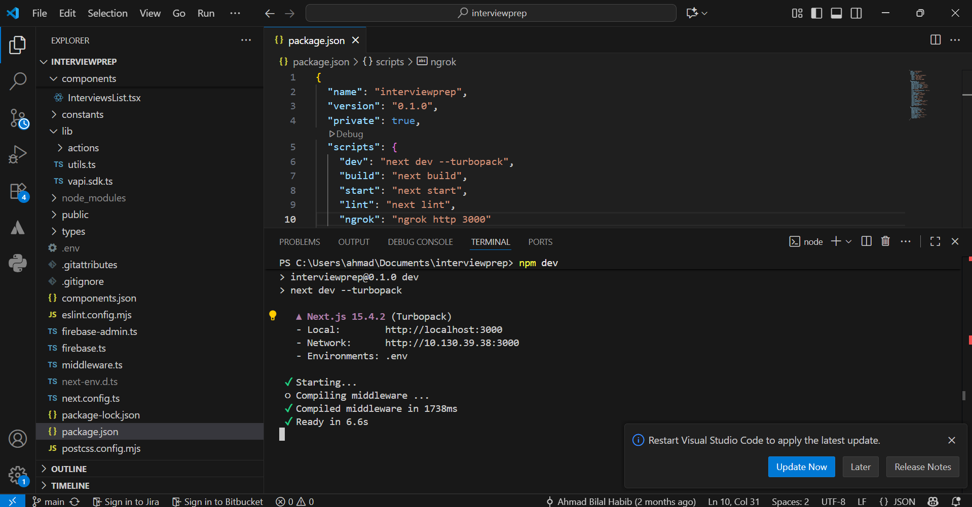
Backend:
Tools / Technologies used:
- Node.js
- Express
- MongoDB (Atlas connection) / Firebase
- Nodemon (for live backend reloading)

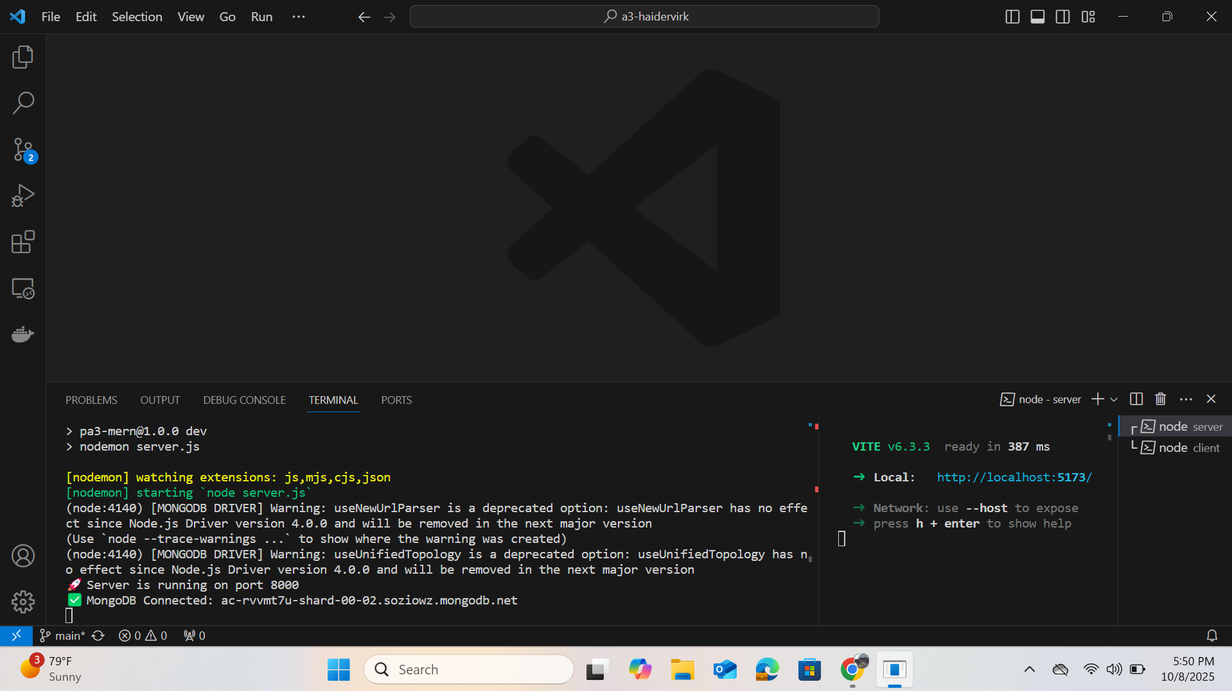

Docker:
Tools / Technologies used:
- Docker 25.0.2
- Docker Desktop

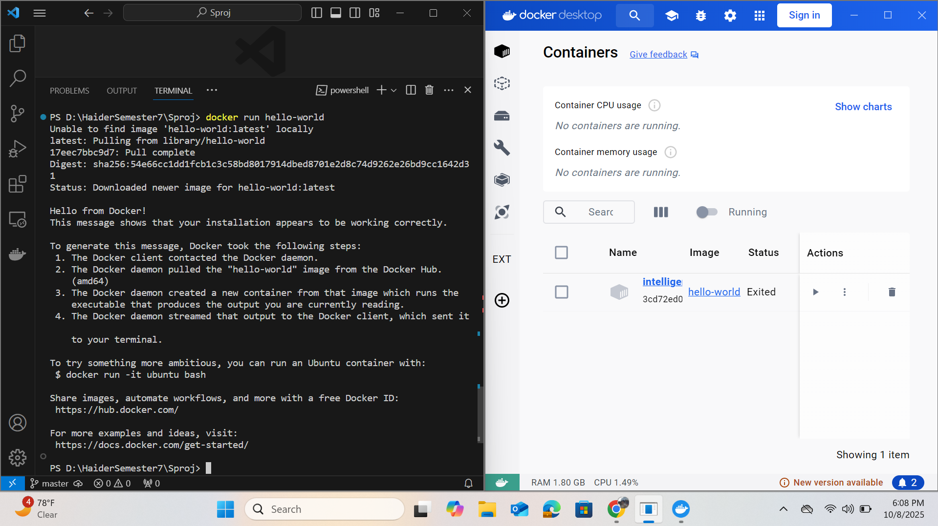

9. Deployment Platform
For deployment of the system, free hosting services will be used for both the frontend and backend to make the application accessible online.
- Backend: The backend will be deployed on Render, a free cloud hosting platform that supports Node.js and Express applications. It allows easy deployment directly from a GitHub repository and provides a public API endpoint accessible to the frontend.
(Alternatively, Vercel may also be considered for hosting Node.js APIs, but Render will be preferred for full backend services with databases.)
- Frontend: The frontend will be deployed on Vercel, which provides fast, reliable, and free hosting for React-based applications. It offers continuous deployment from GitHub and will automatically rebuild the site whenever new commits are pushed.

10. Use of Generative AI

Generative AI will be used in this project for:
- Generating interview questions from job descriptions.
- Conducting conversational interviews with candidates.
- Analyzing candidate responses for tone, clarity, and correctness.
- Adapting dynamically to the user’s performance during the interview

11. Who Did What?

Name of the Team Member | Tasks done
Abdul Rehman | Architecture Diagram and Description
Ahmad Bilal | Justification of the architecture, Pros & Cons and Non functional requirements being fulfilled.
Abdul Samad | Tools and Technologies, Hardware Requirements
Haider Abbas Virk | Development Environment Preparation, Deployment Platform
Muhammad Kabli | Project Risk Management

12. Review checklist

Before submission of this deliverable, the team must perform an internal review. Each team member will review one or more sections of the deliverable.

Section Title | Reviewer Name(s)
Project Risk Management | Abdul Rehman
Development Environment Preparation & Deployment | Ahmad Bilal
Architecture Diagram & Architecture Description | Abdul Samad
Tools and Technologies | Muhammad Kabli
Hardware Requirements | Haider Abbas Virk

